Personal, Social and Emotional Development
- Getting to know who we are and understanding we are unique.
- Getting to know the Foundation Stage classrooms, staff and each other.
- Starting to talk about the way we feel and identifying different feelings we have at different times.
- Learning the Golden Rules to make the right choices at school.
- Learning to reflect on how to put things right.
- Building confidence when things are new.
- Learning to follow instructions.
- Choosing what to do or what is needed to complete a personal goal at big school.
- Learning to play with one or more friends cooperatively together.
- Learning to wash our hands and go to the toilet at school by ourselves.

Physical Development
- Learning about spatial awareness and how to move safely in a large space with others.
- Balancing on one leg.
- Exploring co-ordination and control in footwork moving in different ways.
- Learning to stop and avoid obstacles when travelling.
- Learning and playing playtime games.
- Learning to use new Foundation equipment in Big Outside safely including stepping blocks, balancing beams, climbing apparatus, mud kitchen pulley system, water wall.
- Learning to use balance bikes.
- Making and moving over obstacle courses.
- Practising fine motor control to be able to develop mark making and pencil control.
- Learning how to use scissors.
- Learning how to use cutlery to eat independently.

I am Unique
In this topic we are learning to be part of our Sherrier family and the importance of being kind and making friends. We will explore how we are all special and unique.
EVERYONE IS WELCOME IN OUR FOUNDATION STAGE.

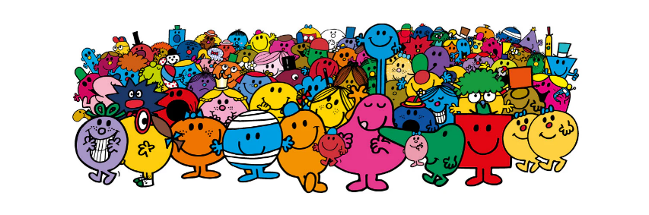
Focused Texts: The Colour Monster by Anna Llenas, Dogger by Shirley Hughes, Hands Are Not for Hitting by M. Agassi, Katie’s Picture Show and Katie and the Mona Lisa by J. Mayhew, The Large Family stories by J. Murphy and Mr Men and Little Miss stories by Roger Hargreaves

Communication and Language
Emphasis of talk for this half term:
WELCOME TO EYFS!
- Meeting and greeting friends and teachers.
- Answering the register.
- Talking to others and learning to take it in turns to speak.
- Learning to listen to your teachers.
- Talking about things that are familiar to them such as their likes, dislikes and interests.
- Exploring what we should and shouldn’t do through role playing.
- Joining in at group times and story times.
- Sharing facts about me.
- Talking about routines throughout the school day and learning class songs and rhymes.

Literacy
- Beginning to hear, say and write initial sounds and to start oral blending.
- Recognising name in different contexts.
- Learning to write own first name.
- Listening to stories with attention and recall.
- Learning to follow text from left to right.
- Using picture clues to help to read repeated phrases and sentences in books.
- Talking about stories heard.
- Experimenting with mark making and writing patterns.
- Giving meaning to marks and labels.
- Using initial sounds to label pictures.
- Using kid writing in personal bookmaking.
- Learning to write letters of their name.
- Practising developing their dominant hand and holding a pencil correctly using ‘froggy fingers’.

Jigsaw Topic: Being Me in my world
During this topic we will learn how to:
- Understand how it feels to belong and that we are similar and different.
- Start to recognise and manage our feelings and be kind to others.
- Work with others to enjoy school and make friends.
- Start to know what being responsible means.

Expressive Arts and Design
- Introduction to the creative room.
- Building confident and creative learners.
- Exploring different materials/experiences.
- Drawing a picture and talking about it including circles, horizontal/vertical lines.
- Building confidence handling materials and exploring techniques.
- Learning how to join materials together.
- Naming colours and knowing how to mix colours.
- Knowing a portrait is a picture of a person.
- Exploring and creating self-portraits.
- Assembling and de-constructing using construction materials and junk modelling.
- Singing nursery rhymes and familiar songs
- Exploring different tools such as scissors
- Using props and materials in role and small world play.
- Exploring pulse in Music.

Understanding of the World
- Exploring who we are, our names, our birthdays and our likes and dislikes.
- Talk about birthdays past and present and how we change in our lives.
- Know that everyone has a different story to tell.
- Identifying members of own family and where they belong in their family in terms of how old they are.
- Understanding that everyone’s family is different
- Talk about different jobs people do in our families.
- Talking about family memories.
- Know and talk about similarities and differences between them and their friends.
- Exploring being part of Sherrier family, class names and school routines.
- Know when and why we come to big school.
- Naming parts of our body and face.
- Exploring the world around us with all of our senses and describing what we see.
- Knowing where we live and what the weather is like where we live. Begin to explore places we have visited.
- Know about our school/classroom and key features of Foundation Stage. Navigate the space both inside and outside.

Religious Education Our Christian Value for the Year is Friendship
Topic: Where do we belong? Part 1
- Where do you belong? What makes us feel special? Explore belonging to our family and our Sherrier family. How do we show everyone is welcome?
- Where do you belong out of school?
- How do you know you belong?
- Explore what groups do religious people belong to?
- What makes Christians believe they are special to God?
- Explore the Hindu festival of light – Diwali.

Mathematics
- Introduction to our Ten Town characters (focussing on numbers 0-5).
- Joining in with counting and rhyming songs.
- Classifying and sorting objects.
- Making sets of objects to 5 saying 1 number name for each item.
- Comparing sets of objects.
- Matching numerals and quantities to 5.
- Ordering numbers up to 5.
- Subitising up to 3.
- Learning dice patterns to 6.
- Counting out loud forwards and backwards.
- Number recognition up to 5.
- Solving problems with numbers up to 5.
- Learning correct number formation up to 5.
- Learning to continue and copy patterns.
- Learning to compare quantities.

Philosophy 4 Children (P4C)
Introduction to P4C rules and skills
Speaking focus will be learning to express a point of view and learning to share our ideas in a sentence.
Key Questions
- What are the Golden Rules and why do we need to follow them?
- What are feelings and how do you feel today?
- Which Mr Men and Little Miss character are you like and why?
- Which character would you like to join our class and why?

